Steps to deploy the asp.net core application is local IIS:

1. Develop the API project [version used .net core 3.1]

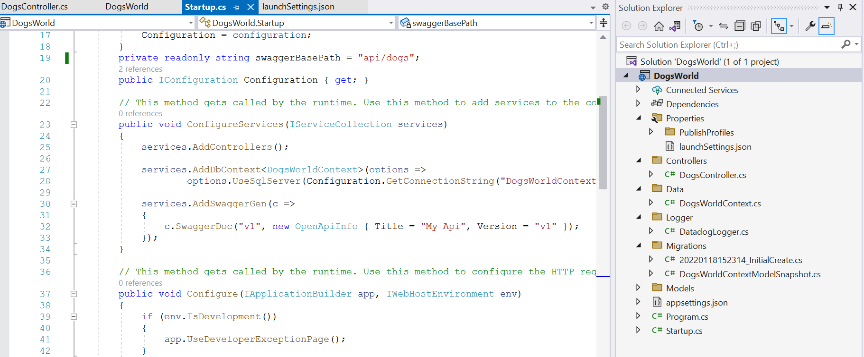

1. Configure the swagger in API project start up. Cs file
2. Install the IIS in computer.-> control panel -> turn windows feature on or off -> select all the IIS related checks in the pop up page and -> click OK.
3. This will install the IIS in our local machine.
4. To check the installation -> use command ‘inetmgr’ from RUN window.
5. IIS window open up if successfully installed. If required restart the computer to reflect the effects in system.
6. Please follow below screen shots.

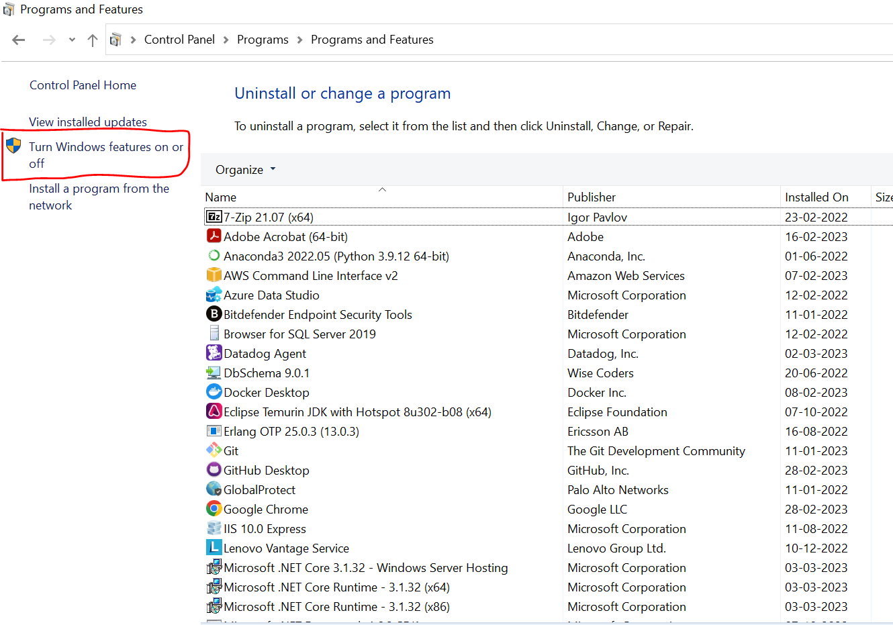

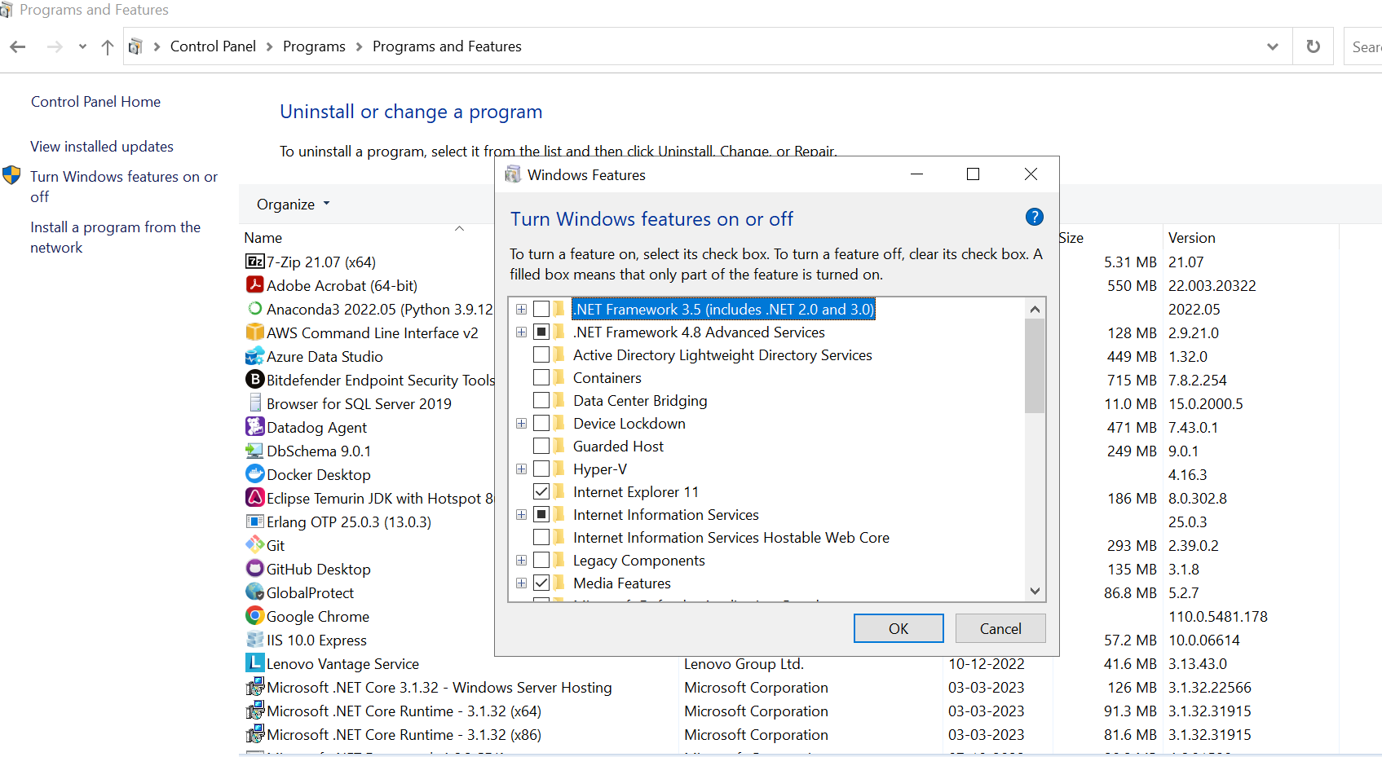

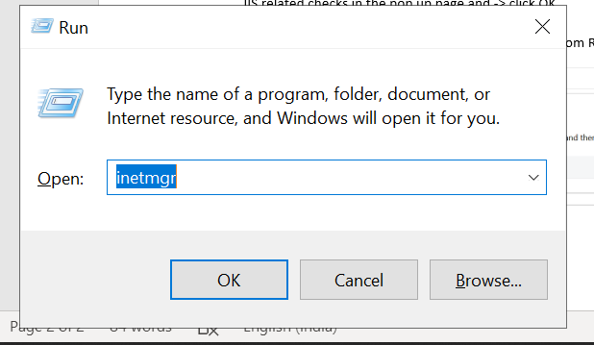

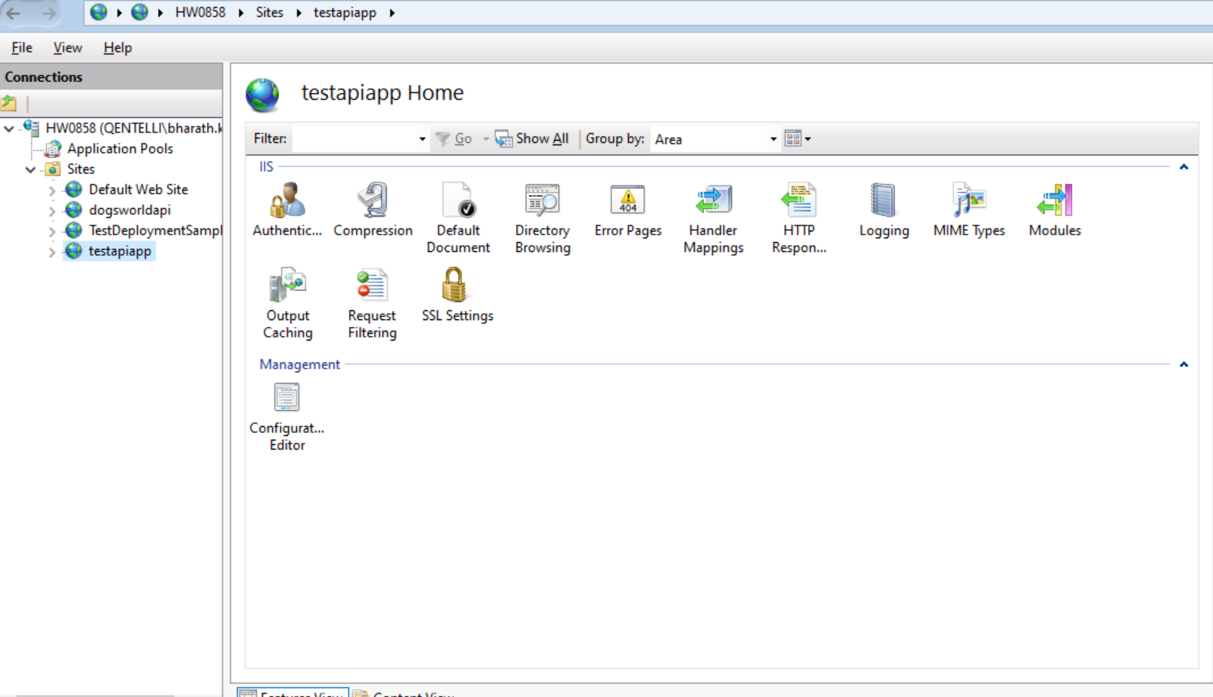

9. Once the installation done, then publish the code from Visual studio into a separate folder.

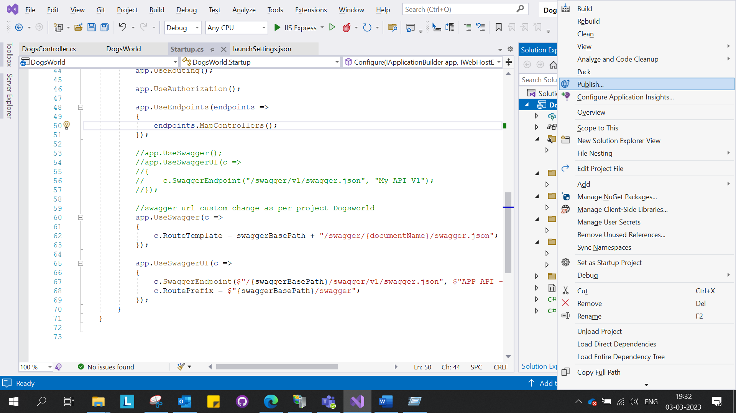

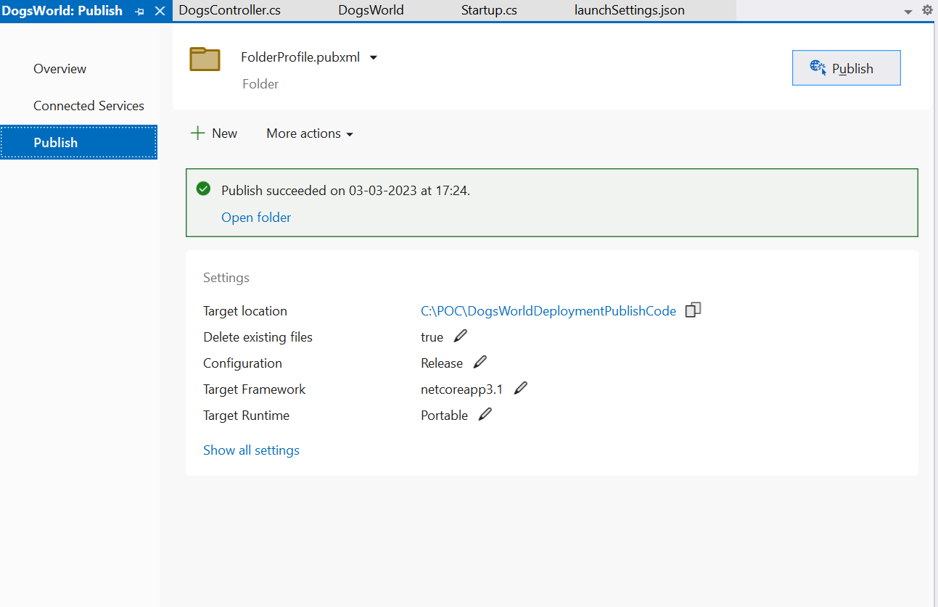

10. Once code is published, before mapping this IIS, we have to install the dot net hosting handler in our system, according to the .net core application.

11. As our application is .net core 3.1, we have to install the dot net hosting handler of supporting version.

[Download .NET Core 3.1 (Linux, macOS, and Windows) (microsoft.com)](https://dotnet.microsoft.com/en-us/download/dotnet/3.1)

Download the dot net hosting bundle for the above site.

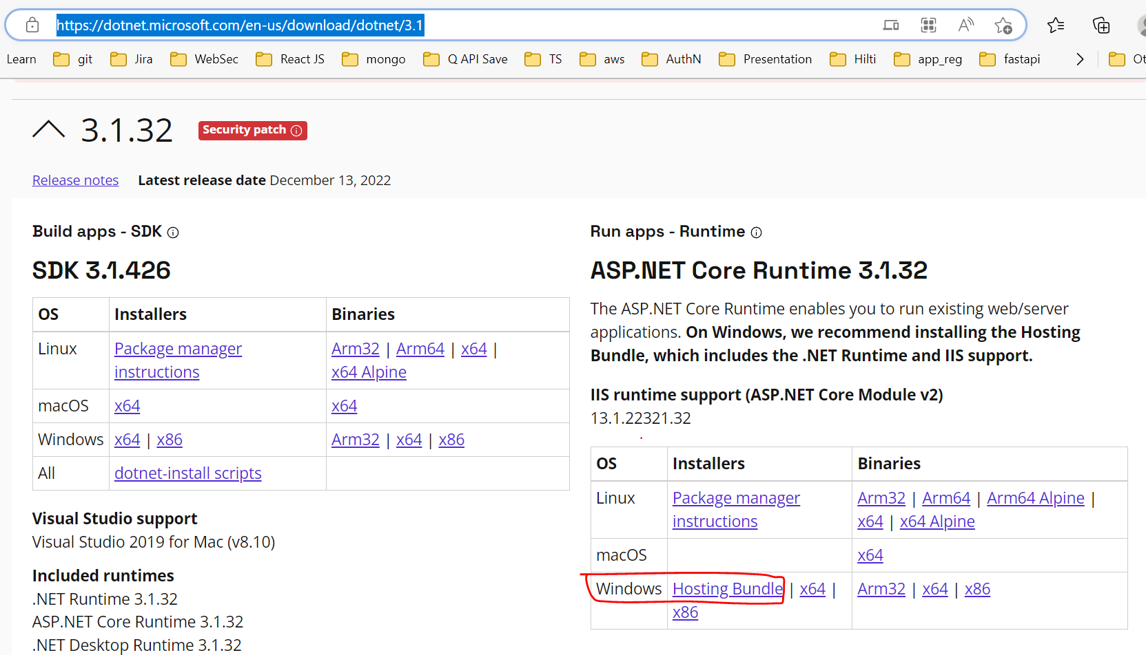

11. Once installed this, go to IIS and check the modules.

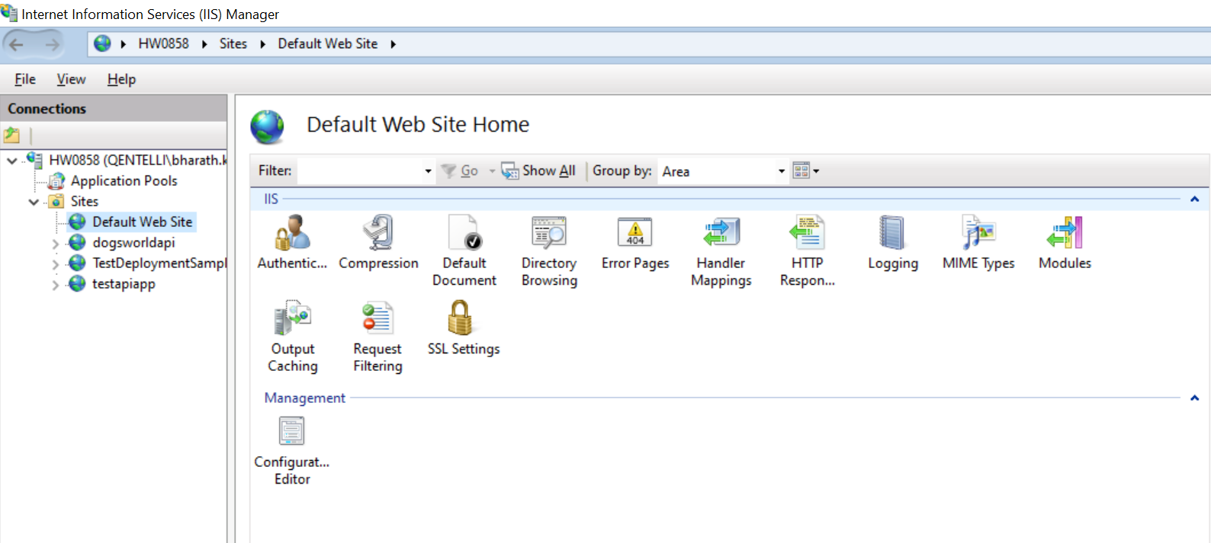

12. click on default website -> and select modules [double click]

13. we are able to see the aspnetcoremoduleV2. If it exists then hosting bundle installed successfully. [u may need to restart the IIS or system, if changes do not reflect after installation]

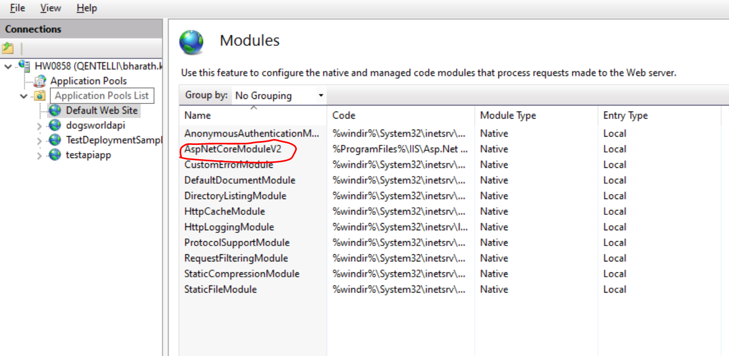

14. now Click on the sites and add web site.

15. Provide the sitename. Map the physical path , port and hostname.

16. refresh the site and browse.

17. make sure, you have the swagger configuration in startup.cs, launch settings and controller routing are in synch. [please refer the DogsWorld or TestAPI applications for reference]

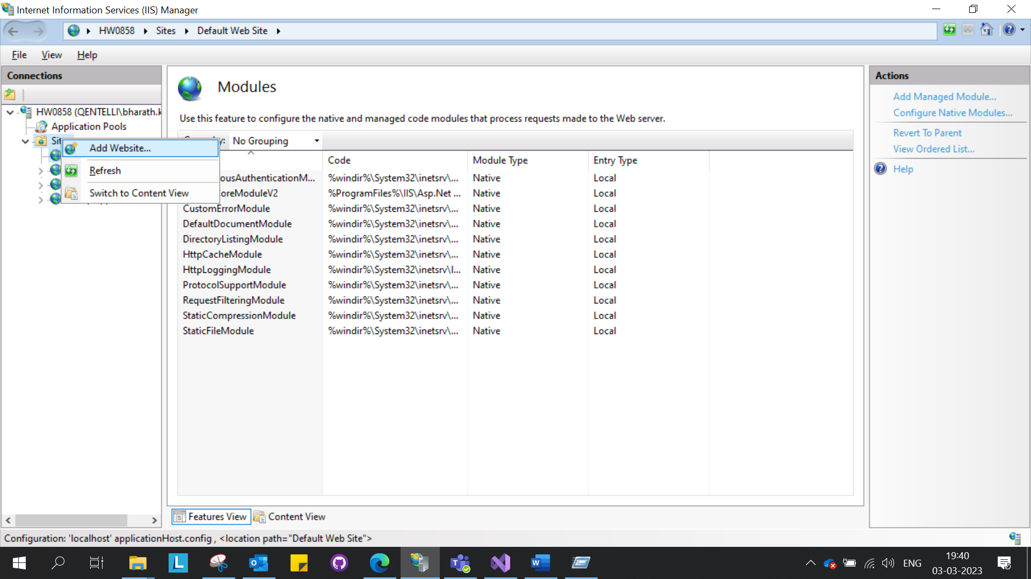

Running application from IIS using hostname provided.[testdeploymentsample.com as host]

* Accessing via swagger [http://testdeploymentsample.com/api/dogs/swagger/index.html]
* Accessing the controller[http://testdeploymentsample.com/api/dogs]

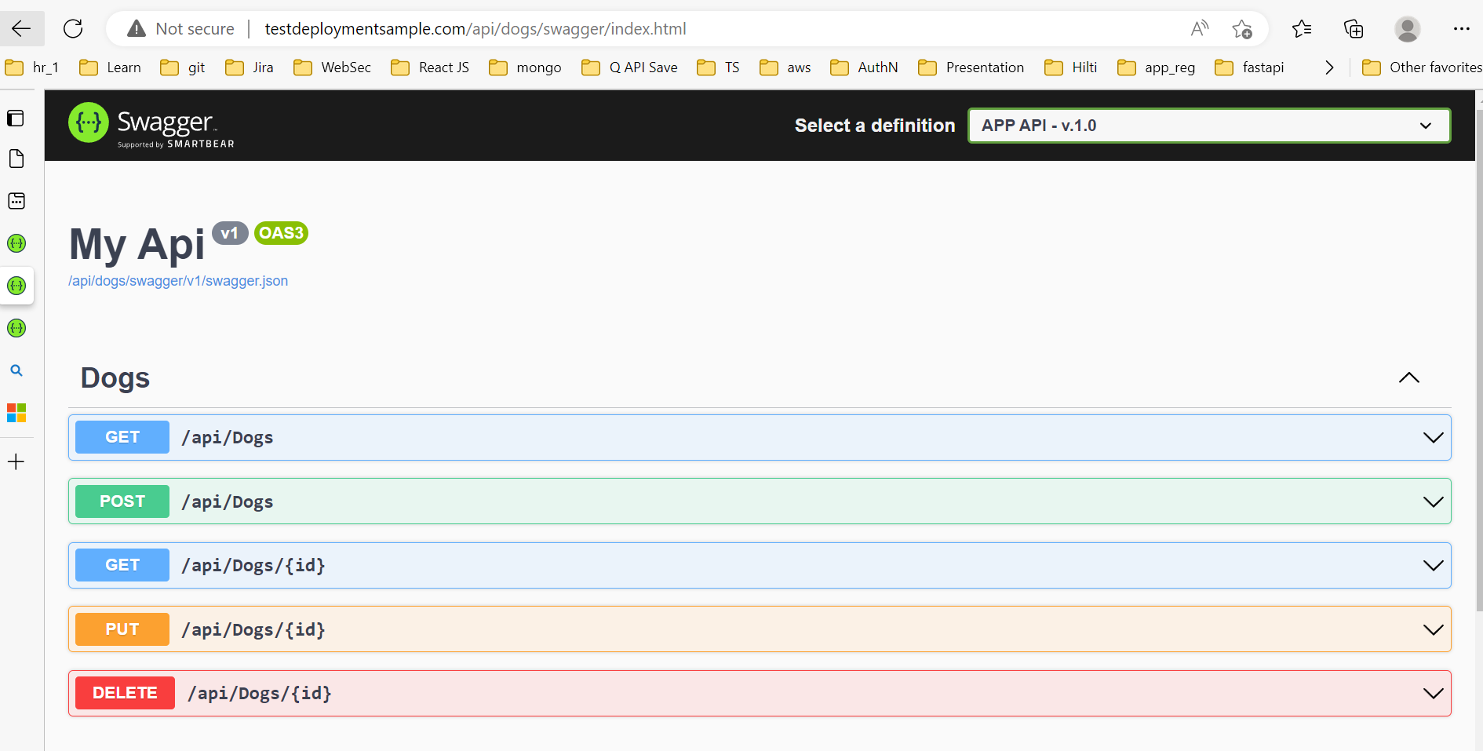

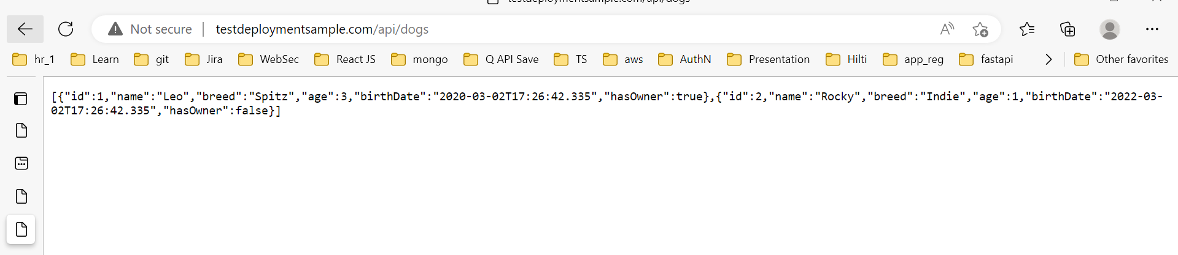

Running application from IIS without hostname provided. [i.e. localhost]

* Accessing via swagger [http://localhost:8086/swagger/index.html]
* Accessing the controller[http://localhost:8086/WeatherForecast]

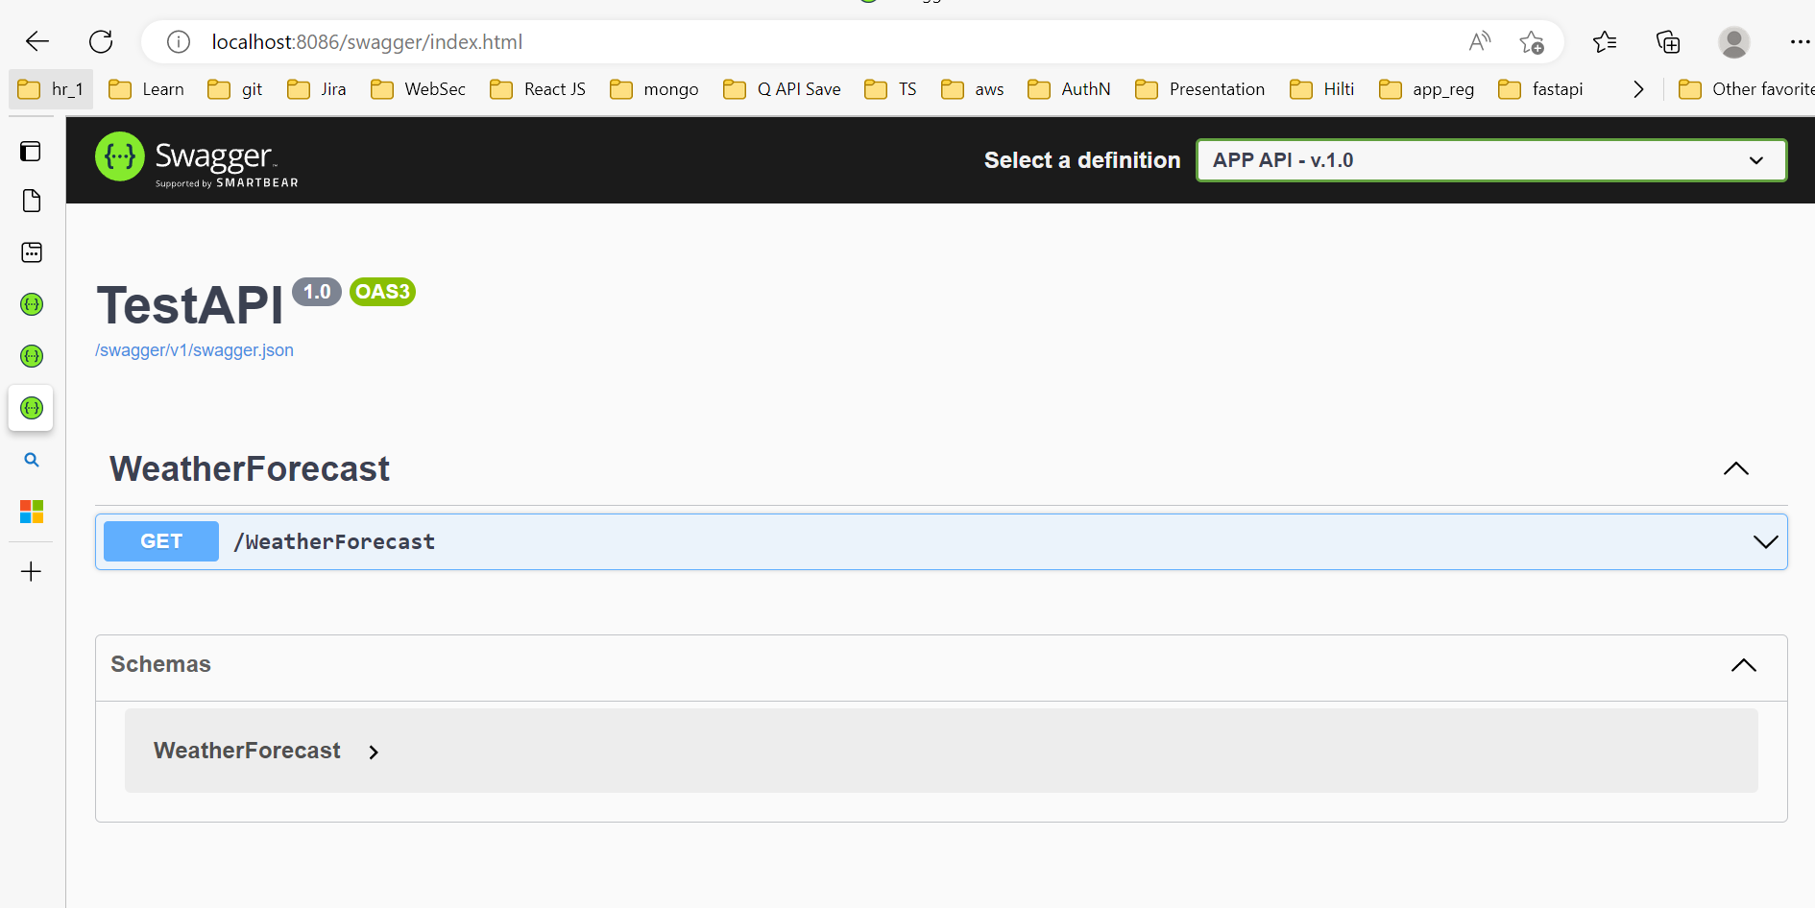

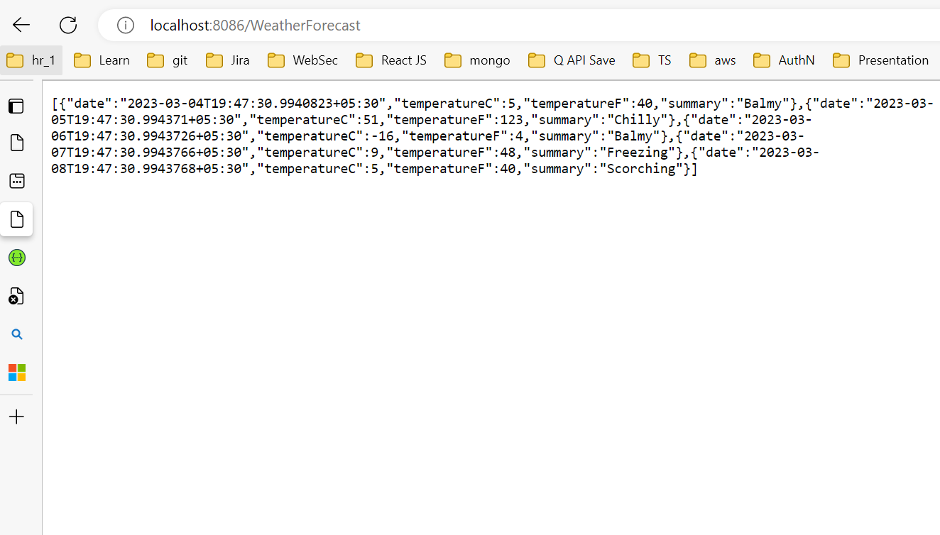

18. Note: some times our application is not accessible and we end up with not reachable page.

19. we have to configure the host in our system.

20. go to path -> C:\Windows\System32\drivers\etc and find the file hosts.

21. we cant modify the file directly here. Move the file from this location to desktop or somewhere , there we can edit it and place the file again in this location.

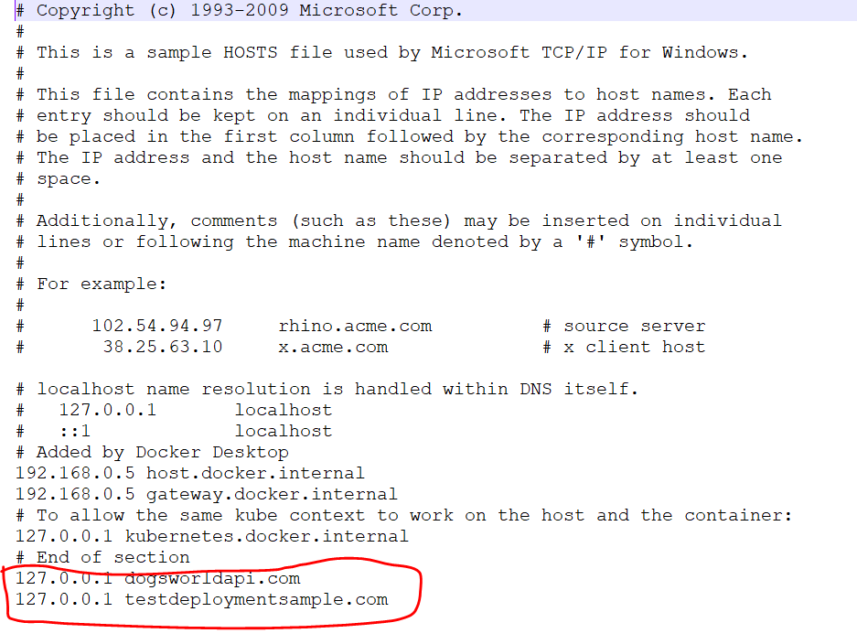

22. Place our url entries in this file and save the changes. This will allow us to access the URLs from the IIS.